**The University of Texas at Arlington**

**INSY 5335 Summer 2015**

**Group #1 Project**

**Submitted to:**

**Professor Radha Mahapatra**

**Submitted by:**

**Ang, Dominique Jeanne**

**Gorde, Aditya**

**Pathak, Surasan**

**Song, Jiangfang**

**Wang, Yang**

**Contact Person:**

***Surasan Pathak***

***Contact number: 469 358-9383***

***E-mail: surasan.pathak@mavs.uta.edu***

**Part II.**

**A. Revised Part I**

**Entity Definition:**

|  |  |
| --- | --- |
| **Employee** | is a person who currently works at OSI |
| **Driver** | is an employee of OSI and delivers the orders |
| **Sales Representative** | is an employee of OSI and takes customer orders |
| **Customer** | is an institutional buyer who places order |
| **Order** | refers to the list of items placed by customer |
| **Item** | refers to individual units which is a part of the collection sold by OSI |
| **Truck** | is used by driver to deliver orders |

**Relationship Matrix:**

|  |  |  |  |  |  |  |  |
| --- | --- | --- | --- | --- | --- | --- | --- |
|  | **Employee** | **Driver** | **Sales**  **Representative** | **Customer** | **Order** | **Item** | **Truck** |
| **Employee** |  | Can be a | Can be a |  |  |  |  |
| **Driver** | Is a kind of |  |  |  |  |  | Assigned to |
| **Sales Representative** | Is a kind of |  |  |  | Takes |  |  |
| **Customer** |  |  |  |  | Places |  |  |
| **Order** |  |  | Taken by | Placed by |  | Contains | Delivered by |
| **Item** |  |  |  |  | Contained in |  |  |
| **Truck** |  | Assigned to |  |  | Delivers |  |  |

**Business Rules:**

Employee can be a driver

Driver is a kind of employee

Employee can be a sales representative

Sales representative is a kind of employee

Each driver is sometimes assigned to one truck

Each truck is sometimes assigned to one driver

Each sales representative always takes one or more orders

Each order is always taken by one sales representative

Each customer always places one or more orders

Each order is always placed by one customer

Each order always contains one or more items

Each item is sometimes included in one or more orders

Each truck sometimes delivers one or more orders

Each order is sometimes delivered by one or more trucks

**B. 1st ER Diagram: Conceptual Model**

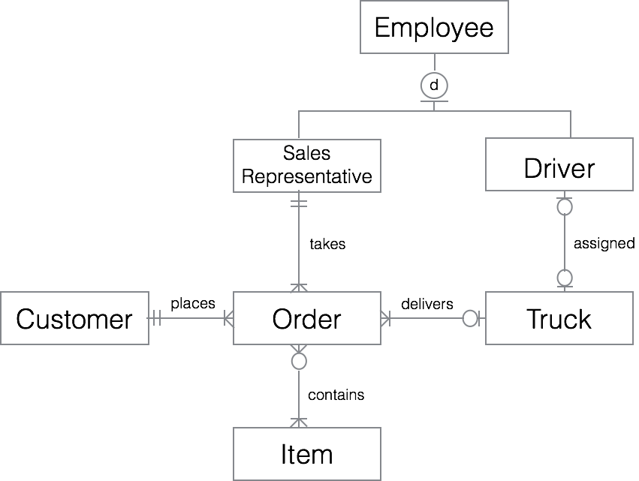

**2nd ER Diagram: Internal Model**

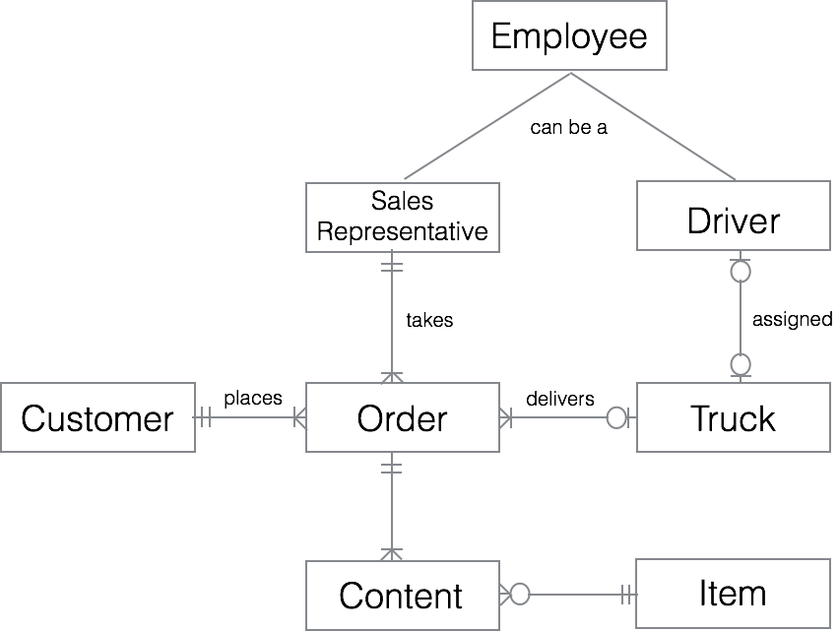

**C. Relational Schema**

*Note:*

*(*) will be denoted as both a primary key and a foreign key*

*Primary keys are in uppercase and underlined*

*Foreign keys are in lowercase and underlined*

EMPLOYEE (EID, Ssn, E_fname, E_lname, E_street, E_city, E_state, E_zip, E_type, E_phone)

SALES REP (EID*, S_salary, S_commission, Oid)

DRIVER (EID*, D_lin, D_lie, D_salary, T_vnum)

*where FK is: T_vnum*

TRUCK (T_VNUM, T_pnum, T_lexp, T_iexp)

CUSTOMER (C_NUM, C_name, C_fname, C_lname, C_bstreet, C_bcity, C_bstate, C_bzip, Phone)

ITEM (I_ID, I_name, I_upr, I_quan)

ORDER (OID, O_dstreet, O_dcity, O_dstate, O_dzip, O_ddate, T_vnum, Eid, C_num) *where FK are: T_vnum, Eid, C_num*

CONTENT (Oid, I_id, O_Quan)

*where FK are: Oid and I_id*

**D. Data Dictionary**

|  |  |  |  |  |  |  |
| --- | --- | --- | --- | --- | --- | --- |
| Table Name | Attribute Name | Contents | Type | Required | PK or FK | FK Referenced Table |
| aag3286.  employee | EID | Employee ID | Number(6) | Y | PK |  |
| SSN | Employee Social Security Number | Number(10) | Y |  |  |
| E_FNAME | Employee First Name | Varchar(20) | Y |  |  |
| E_LNAME | Employee Last Name | Varchar(20) | Y |  |  |
| E_STREET | Employee Street | Char(5) | Y |  |  |
| E_CITY | Employee City | Varchar(20) | Y |  |  |
| E_STATE | Employee State | Varchar(20) | Y |  |  |
| E_ZIP | Employee Zip Code | Number(5) | Y |  |  |
| E_TYPE | Employee Job Type | Char(20) | Y |  |  |
| E_PHONE | Employee Phone Number | Number(10) | Y |  |  |

|  |  |  |  |  |  |  |
| --- | --- | --- | --- | --- | --- | --- |
| Table Name | Attribute Name | Contents | Type | Required | PK or FK | FK Referenced Table |
| aag3286.  sales_rep | EID | Employee ID | Number(6) | Y | PK, FK | EID |
| S_SALARY | Sales Representative Salary | Number(12) | Y |  |  |
| S_COMMISSION | Sales Representative Commission | Number(12) | Y |  |  |
| OID | Order ID | Number(10) | Y |  |  |

|  |  |  |  |  |  |  |
| --- | --- | --- | --- | --- | --- | --- |
| Table Name | Attribute Name | Contents | Type | Required | PK or FK | FK Referenced Table |
| aag3286.  driver | EID | Employee ID | Number(6) | Y | PK, FK | EID |
| D_LIN | Driver’s License Number | Number(10) | Y |  |  |
| D_LIE | Driver’s License Expiration Date | Date |  |  |  |
| D_SALARY | Driver Salary | Number(12) | Y |  |  |
| T_VNUM | Truck Vehicle Number | Char(9) | Y | FK | T_VNUM |

|  |  |  |  |  |  |  |
| --- | --- | --- | --- | --- | --- | --- |
| Table Name | Attribute Name | Contents | Type | Required | PK or FK | FK Referenced Table |
| aag3286.  trucks | T_VNUM | Truck Vehicle Number | Char(9) | Y | PK |  |
| T_PNUM | Truck License Plate | Char(9) | Y |  |  |
| T_LEXP | Truck License Expiration Date | Date | Y |  |  |
| T_IEXP | Truck Inspection Date | Date | Y |  |  |

|  |  |  |  |  |  |  |
| --- | --- | --- | --- | --- | --- | --- |
| Table Name | Attribute Name | Contents | Type | Required | PK or FK | FK Referenced Table |
| aag3286.  customer | C_NUM | Customer Account Number | Number(10) | Y | PK |  |
| C_NAME | Company Name | Char(20) | Y |  |  |
| C_FNAME | Contact Person First Name | Varchar(20) | Y |  |  |
| C_LNAME | Contact Person  Last Name | Varchar(20) | Y |  |  |
| C_BSTREET | Customer Street Name | Char(5) | Y |  |  |
| C_BCITY | Customer City | Number(5) | Y |  |  |
| C_BSTATE | Customer State | Varchar(20) | Y |  |  |
| C_BZIP | Customer Zip Code | Varchar(20) | Y |  |  |
| PHONE | Customer Phone Number | Number(10) | Y |  |  |

|  |  |  |  |  |  |  |
| --- | --- | --- | --- | --- | --- | --- |
| Table Name | Attribute Name | Contents | Type | Required | PK or FK | FK Referenced Table |
| aag3286.  item | I_ID | Item ID | Number(10) | Y | PK |  |
| I_NAME | Item Name | Char(10) | Y |  |  |
| I_UPR | Unit Price | Number(9,2) | Y |  |  |
| I_QUAN | Item Quantity | Number(5) | Y |  |  |

|  |  |  |  |  |  |  |
| --- | --- | --- | --- | --- | --- | --- |
| Table Name | Attribute Name | Contents | Type | Required | PK or FK | FK Referenced Table |
| aag3286.  o_form | OID | Order Number | Number(10) | Y | PK |  |
| O_DSTREET | Delivery Street | Char(5) |  |  |  |
| O_DCITY | Delivery City | Number(5) |  |  |  |
| O_DSTATE | Delivery State | Varchar(20) |  |  |  |
| O_DZIP | Delivery Zip Code | Varchar(20) |  |  |  |
| O_DDATE | Order Date | Date |  |  |  |
| T_VNUM | Truck Vehicle Number | Char(9) | Y | FK | T_VNUM |
| EID | Employee ID | Number(6) | Y | FK | EID |
| C_NUM | Customer Account Number | Number(10) | Y | FK | C_NUM |

|  |  |  |  |  |  |  |
| --- | --- | --- | --- | --- | --- | --- |
| Table Name | Attribute Name | Contents | Type | Required | PK or FK | FK Referenced Table |
| aag3286.  content | OID | Order Number | Number(10) | Y | FK | OID |
| I_ID | Item ID | Number(10) | Y | FK | I_ID |
| O_QUAN | Order Quantity | Number(3) | Y |  |  |

**E. Tables**

**1. Employee:**

SQL> describe aag3286.employee;

Name Null? Type

---------------------- ----------- -------------

EID NOT NULL NUMBER(6)

SSN NOT NULL NUMBER(9)

E_FNAME NOT NULL VARCHAR2(20)

E_LNAME NOT NULL VARCHAR2(20)

E_STREET NOT NULL VARCHAR2(20)

E_CITY NOT NULL VARCHAR2(20)

E_STATE NOT NULL VARCHAR2(20)

E_ZIP NOT NULL NUMBER(5)

E_TYPE NOT NULL CHAR(20)

E_PHONE NUMBER(10)

SQL> select*

2 from aag3286.employee;

EID SSN E_FNAME E_LNAME E_STREET

------ -------- ----------- ------------ ------------ ----------

E_CITY E_STATE E_ZIP E_TYPE E_PHONE

--------- ---------- ----------- ---------

123456 983742983 John Smith Monkey Drive

Arlington TX 76021 D 8177622391

123578 446797523 Franklin Wong Obama Street

Arlington TX 76028 D 8327192831

234567 374634744 Alicia Zelaya Taylor Road Houston TX 74021 D 7483769123

385797 873838213 Ahmad Jabbar Dreamer Drive Dallas TX 77213 D 7482921231

349820 389282123 James Bond Orange Avenue

Austin TX 73991 D 3892384723

374662 948372811 James Brog Bang Avenue Austin TX 72016 S 5847329821

328392 392835738 Ramesh Narayh Cowboy Drive Arlington TX 76219 S 4858927231

329375 359829238 Roger Wallace Alibaba Avenue Austin TX 73928 S 4895378262

492859 283947532 Joyce English Moon Road Arlington TX 77201 S 8478266123

390242 498579833 Michael Jordan Apple Drive Austin TX 72129 S 8947923123

10 rows selected.

**2. Sales Representative:**

SQL> describe aag3286.sales_rep;

Name Null? Type

----------------------------- -------- -------------

EID NOT NULL NUMBER(6)

S_SALARY NOT NULL NUMBER(6)

S_COMMISSION NUMBER(6)

OID NOT NULL NUMBER(6)

SQL> select*

2 from aag3286.sales_rep;

EID S_SALARY S_COMMISSION OID

---------- ---------- ------------ ----------

374662 40000 10000 123456

328392 50000 15000 234567

329375 45000 5600 345678

492859 60000 18000 456789

390242 38000 10000 567890

**3. Driver:**

SQL> describe aag3286.driver;

Name Null? Type

----------------------------------------- -------- -------------

EID NOT NULL NUMBER(6)

D_LIN NOT NULL NUMBER(6)

D_LIE NOT NULL DATE

D_SALARY NOT NULL NUMBER(6)

T_VNUM CHAR(9)

SQL> select*

2 from aag3286.driver;

EID D_LIN D_LIE D_SALARY T_VNUM

---------- ---------- --------- ---------- ---------

123456 111111 02-FEB-18 30000 abc111

123578 222222 03-MAY-20 40000 abc222

234567 333333 05-JUL-21 25000 abc333

385797 444444 01-SEP-19 25000 abc444

349820 555555 01-FEB-20 40000 abc555

**4. Trucks:**

SQL> describe aag3286.trucks;

Name Null? Type

------------------------- -------- -------------

T_VNUM NOT NULL CHAR(9)

T_PNUM NOT NULL CHAR(9)

T_LEXP NOT NULL DATE

T_IEXP NOT NULL DATE

SQL> select*

2 from aag3286.trucks;

T_VNUM T_PNUM T_LEXP T_IEXP

--------- --------- --------- ---------

abc111 dxs123 23-JAN-16 10-JUN-17

abc222 dxs234 11-JUN-17 20-JAN-16

abc333 dxs345 05-AUG-17 15-FEB-16

abc444 dxs456 13-FEB-18 22-SEP-16

abc555 dxs567 09-DEC-18 08-OCT-16

**5. Customer:**

SQL> describe aag3286.customer;

Name Null? Type

-------------------------- ---------------- -------------

C_NUM NOT NULL NUMBER(10)

C_NAME NOT NULL VARCHAR2(20)

C_FNAME NOT NULL VARCHAR2(20)

C_LNAME NOT NULL VARCHAR2(20)

C_BSTREET NOT NULL VARCHAR2(20)

C_BCITY NOT NULL VARCHAR2(20)

C_BSTATE NOT NULL VARCHAR2(20)

C_BZIP NOT NULL NUMBER(5)

PHONE NUMBER(10)

SQL> select*

2 from aag3286.customer;

C_NUM C_NAME C_FNAME C_LNAME

-------------- ------------------ --------------- -------------

C_BSTREET C_BCITY C_BSTATE C_BZIP PHONE

------------------ ------------ -------- -------- ------------

1001151037 Aqua Corporation Dominique Ang

Matilda Street Dallas TX 75206 2141234567

1001153286 ABC Corporation Aditya Gorde

Matlock Road Arlington TX 76018 8321243568

1000800814 Sam Enterprise Surasan Pathak

W Irving Blvd Irving TX 75060 4327654321

1000560998 Coach Express Jiangfang Song

W Park Row Arlington TX 76013 2145890768

1001126267 Texas Enterprise Yang Wang

South Storey Road Irving TX 75060 4325678954

**6. Item:**

SQL> describe aag3286.item;

Name Null? Type

----------------------- --------- -------------

I_ID NOT NULL NUMBER(10)

I_NAME NOT NULL VARCHAR2(20)

I_UPR NOT NULL NUMBER(9,2)

I_QUAN NUMBER(5)

SQL> select*

2 from aag3286.item;

I_ID I_NAME I_UPR I_QUAN

---------- -------------------- ---------- ----------

42873 PAPER 5 100

42894 PEN 10 50

43872 PRINTER 9 3

49382 LAPTOP 300 5

41292 PROJECTOR 150 6

48372 STAPLER 2.38 10

6 rows selected.

**7. Order:**

SQL> describe aag3286.o_form;

Name Null? Type

--------------------------- ---------- -------------

OID NOT NULL NUMBER(6)

O_DSTREET VARCHAR2(20)

O_DCITY VARCHAR2(20)

O_DSTATE CHAR(10)

O_DZIP NUMBER(5)

O_DDATE DATE

T_VNUM NOT NULL CHAR(9)

EID NOT NULL NUMBER(6)

C_NUM NOT NULL NUMBER(10)

SQL> select*

2 from aag3286.o_form;

OID O_DSTREET O_DCITY O_DSTATE O_DZIP

------------ --------------- ---------------- ----------- -------

O_DDATE T_VNUM EID C_NUM

------------ --------------- ---------- ----------

123456 Main Street Arlington TX 76013

01-JAN-15 abc222 374662 1001153286

234567 Greek Row Arlington TX 76013

10-DEC-15 abc333 328392 1001151037

567890 Cooper Street Arlington TX 76012

10-AUG-15 abc111 390242 1000800814

456789 Melody Lane Dallas TX 75206

01-OCT-15 abc444 492859 1001126267

345678 Stafford Drive Arlington TX 76012

03-AUG-15 abc111 329375 1000560998

**8. Content:**

SQL> describe aag3286.content;

Name Null? Type

----------------------- -------- -------------

OID NOT NULL NUMBER(6)

I_ID NOT NULL NUMBER(10)

O_QUAN NOT NULL NUMBER(3)

SQL> select*

2 from aag3286.content;

OID I_ID O_QUAN

---------- ---------- ----------

123456 42873 2

123456 42894 10

567890 41292 2

456789 49382 4

345678 42894 15

345678 48372 5

6 rows selected.

**F. SQL Queries**

**1. List all customer names, addresses, contact person names and phone numbers**

SQL> select c_name, c_bstreet, c_bcity, c_bstate, c_bzip,

2 c_fname, c_lname, phone

3 from aag3286.customer;

C_NAME C_BSTREET C_BCITY C_BSTATE

-------------------- -------------------- ----------- ----------- C_BZIP C_FNAME C_LNAME PHONE

--------- --------------- -------------- ------------

Aqua Corporation Matilda Street Dallas TX

75206 Dominique Ang 2141234567

ABC Corporation Matlock Road Arlington TX

76018 Aditya Gorde 8321243568

Sam Enterprise W Irving Blvd Irving TX

75060 Surasan Pathak 4327654321

Coach Express W Park Row Arlington TX

76013 Jiangfang Song 2145890768

Texas Enterprise South Storey Road Irving TX

75060 Yang Wang 4325678954

**2. Pick an order and get all information about that order that are included on the order form**

SQL> select o.oid, o.o_dstreet, o.o_dcity, o.o_dstate, o.o_dzip,

2 e.e_fname, e.e_lname, c.c_num, c.c_name, c.c_fname,

3 c.c_lname, c.c_bstreet, c.c_bcity, c.c_bstate, c.c_bzip,

4 c.phone

5 from aag3286.o_form o, aag3286.customer c, aag3286.employee e

6 where o.c_num=c.c_num

7 and o.eid=e.eid

8 and o.oid=345678;

OID O_DSTREET O_DCITY O_DSTATE O_DZIP

------------ ----------------- ----------- ------------- --------

E_FNAME E_LNAME C_NUM C_NAME

------------ ---------------- --------------- -------------------

C_FNAME C_LNAME C_BSTREET C_BCITY

------------ ---------------- --------------- -------------------

C_BSTATE C_BZIP PHONE

------------ ----------- -------------

345678 Stafford Drive Arlington TX 76012

Roger Wallace 1000560998 Coach Express

Jiangfang Song W Park Row Arlington TX 76013 2145890768

SQL> select co.oid, co.i_id, i.i_name, co.o_quan, i.i_upr

2 from aag3286.content co, aag3286.item i

3 where co.i_id=i.i_id

4 and co.oid=345678;

OID I_ID I_NAME O_QUAN I_UPR

---------- ---------- -------------------- ---------- ----------

345678 42894 PEN 15 10

345678 48372 STAPLER 5 2.38

**3. What is the phone number of the sales rep who took order in the query above?**

SQL> select e_phone

2 from aag3286.o_form o, aag3286.employee e

3 where o.eid=e.eid

4 and o.oid=345678;

E_PHONE

----------

4895378262

**4. Pick a driver and list all orders (order numbers only) delivered by him/her**

SQL> select o.oid

2 from aag3286.o_form o, aag3286.driver d

3 where o.t_vnum=d.t_vnum

4 and d.eid=123456;

OID

----------

567890

345678

**5. What is the total value of all inventory items that have unit prices exceeding $25?**

SQL> select sum(i_upr*i_quan)

2 from aag3286.item

3 where i_upr > 25;

SUM(I_UPR*I_QUAN)

-----------------

2400